**JAVA MODULE END EXAM**

**220940325013_Anushka Umbre_DBDA**

Q. 1

Sol: import java.util.*;

class Question_1

{

public static void main(String args[])

{

ArrayList<String> colors= new ArrayList<String>();

colors.add("Red");

colors.add("Yellow");

colors.add("Green");

colors.add("Blue");

System.out.println("Array List: "+ colors);

System.out.println("Iteration using for-each loop");

for(int i=0; i<colors.size(); i++)

{

System.out.print(colors.get(i));

System.out.print(" , ");

}

}

}

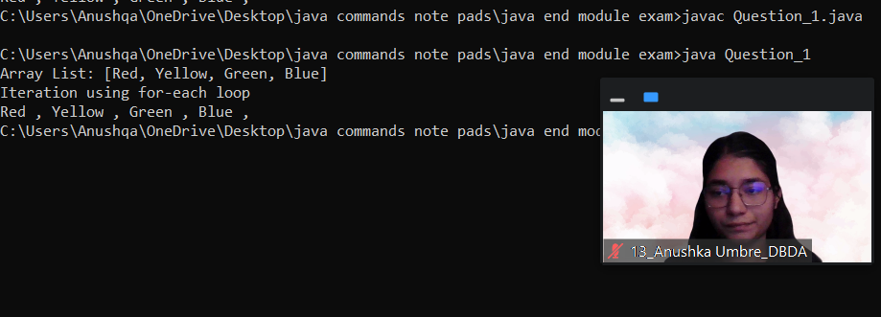

Q.2.

Sol:

import java.util.Scanner;

class BankAccount

{

int accno;

double balance;

Scanner sc= new Scanner(System.in);

BankAccount(int a, double b)

{

this.accno=a;

this.balance=b;

}

void withdraw() throws Exception

{

double amt;

System.out.println("Enter the amount you want to withdraw");

amt=sc.nextDouble();

if(balance>=amt)

{

balance=balance-amt;

System.out.println("Balance after withdrawl: "+ balance);

}

else

{

throw new Exception("Insufficient balance!!");

}

}

void deposit()

{

long amt;

System.out.println("Enter the amount you want to deposit: ");

amt=sc.nextLong();

if(amt>0)

{

balance=balance+amt;

System.out.println("The balance amounnt is: " + balance);

}

else

{

System.out.println("Invalid amount");

}

}

void show()

{

System.out.println("The account number is: "+ accno);

System.out.println("Balance : "+ balance);

}

}

class Question_2

{

public static void main(String args[])

{

BankAccount ba=new BankAccount(1234, 10000);

Scanner sc= new Scanner(System.in);

ba.show();

ba.deposit();

ba.show();

try

{

ba.withdraw();

}

catch(Exception e)

{

System.out.println(e);

}

ba.show();

}

}

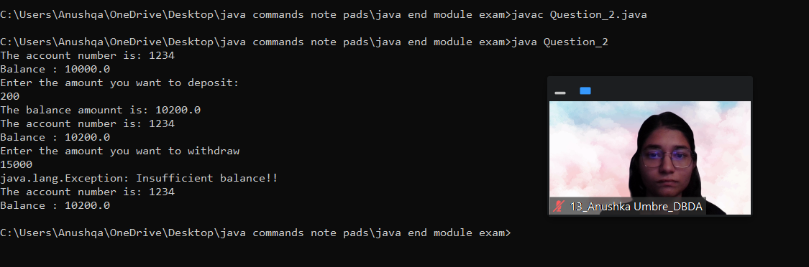

Q.3

Sol:

class Shape

{

void draw()

{

System.out.println("Drawing the shape");

}

void erase()

{

System.out.println("Erasing the shape");

}

}

class Circle extends Shape

{

void draw()

{

System.out.println("Drawing the Circle");

}

void erase()

{

System.out.println("Erasing the Circle");

}

}

class Triangle extends Shape

{

void draw()

{

System.out.println("Drawing the Triangle");

}

void erase()

{

System.out.println("Erasing the Triangle");

}

}

class Square extends Shape

{

void draw()

{

System.out.println("Drawing the Square");

}

void erase()

{

System.out.println("Erasing the Square");

}

}

class Question_3

{

public static void main(String args[])

{

Shape c= new Circle();

Shape t= new Triangle();

Shape sq=new Square();

c.draw();

c.erase();

t.draw();

t.erase();

sq.draw();

sq.erase();

}

}

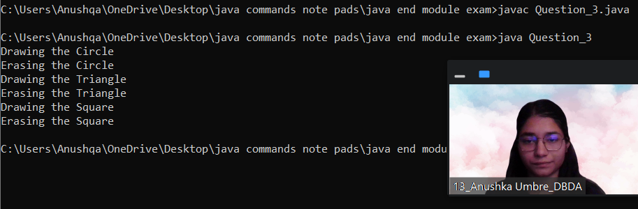

Q.4.

Sol:

import java.util.Scanner;

class GrandParents

{

String grandFatherName;

String grandMotherName;

GrandParents(String grandFatherName, String grandMotherName)

{

this.grandFatherName=grandFatherName;

this.grandMotherName=grandMotherName;

System.out.println("Grand Father's name is: "+grandFatherName);

System.out.println("Grand Mother's name is: "+grandMotherName);

}

}

class Parent extends GrandParents

{

String FatherName;

String MotherName;

Parent(String FatherName, String MotherName,String grandFatherName, String grandMotherName)

{

super(grandFatherName,grandMotherName);

this.FatherName=FatherName;

this.MotherName=MotherName;

System.out.println("Father's name is: "+FatherName);

System.out.println("Mother's name is: "+MotherName);

}

Parent(String grandFatherName, String grandMotherName)

{

super(grandFatherName,grandMotherName);

}

}

class Child extends Parent

{

Child(String FatherName, String MotherName,String grandFatherName, String grandMotherName)

{

super(FatherName,MotherName,grandFatherName,grandMotherName);

}

public static void main(String args[])

{

Child c= new Child("Aviral","Anjana","Sailesh","Apurva");

System.out.println(c.FatherName+" "+c.MotherName+" "+c.grandFatherName+" "+c.grandMotherName);

}

}

